Biometric Face Recognition System
Project Report
Dataset: ORL / AT&T (Olivetti) Face Database
Methods: PCA (Eigenfaces) & LBP (Local Binary Patterns)

1. Database Description
The ORL/AT&T (Olivetti) Face Database is one of the most widely used benchmark datasets in biometric face recognition research. It was created at the Olivetti Research Laboratory in Cambridge, UK, and is a standard reference for evaluating recognition algorithms.

1.1 Dataset Characteristics
Number of subjects: 40 distinct individuals
- Total images: 400 (10 images per subject)
- Image resolution: 64 × 64 pixels, grayscale
- Pixel value range: [0, 1] (normalised float)
- Variations across images: lighting conditions, facial expressions (open/closed eyes, smiling/not smiling), facial details (glasses/no glasses), and small head pose variations

1.2 Train / Test Split
The dataset was divided per subject to ensure every identity appears in both training and testing:

Split | Images / Subject | Total Images
Training (80%) | 8 | 320
Testing (20%) | 2 | 80
Total | 10 | 400

This per-subject stratified split guarantees that each subject contributes to the test set, preventing identity bias and ensuring a fair evaluation of the recognition system.

2. Method Description
Two independent feature extraction methods were implemented and compared. Both methods share a common preprocessing stage and use cosine similarity for matching.

2.1 Preprocessing
Before feature extraction, each image undergoes the following steps:

- Flattening: the 64 × 64 image is converted into a 4,096-dimensional vector.
- Per-image normalisation: the mean pixel value is subtracted and the result is divided by the standard deviation. This produces a zero-mean, unit-variance representation that compensates for global illumination differences.

Normalisation is critical in face recognition because the same face photographed under different lighting conditions can produce very different raw pixel values. After normalisation, only the relative structure of the face (edges, shadows, regions) remains.

2.2 Method 1: PCA – Eigenfaces
Principal Component Analysis (PCA) is a dimensionality reduction technique that finds the directions of maximum variance in the training data. When applied to face images, these principal components are called Eigenfaces.

- The 320 training images (each 4,096-dimensional) are used to compute a covariance matrix.
- The top 100 principal components (eigenvectors) are retained, capturing 88.0% of the total variance.
- Each image is then projected onto these 100 components, producing a compact 100-dimensional feature vector.
- Whitening is applied so that all components have equal variance, preventing dominant components from overshadowing weaker but potentially discriminative ones.

The resulting features encode the most discriminative facial structures (overall brightness distribution, eye positions, nose shape, mouth region) in a compact form that is efficient to compare.

2.3 Method 2: LBP – Local Binary Patterns
Local Binary Patterns (LBP) is a texture descriptor that captures local micro-patterns in an image. It is computationally lightweight and invariant to monotonic greyscale changes.

- For each pixel, the values of its 16 neighbours (arranged on a circle of radius 2) are compared to the centre pixel.
- Each comparison produces a binary digit (1 if the neighbour is brighter, 0 otherwise), giving an 18-bit pattern per pixel.
- A histogram of all LBP codes in the image is computed and normalised, producing an 18-dimensional feature vector.

LBP captures fine texture details but loses spatial layout information entirely, which limits its effectiveness for holistic face recognition. This contrast with PCA is reflected clearly in the results.

2.4 Matching
Both methods use cosine similarity as the matching metric. For two feature vectors a and b, the similarity score is computed as:

score(a, b) = (a · b) / (||a|| × ||b||)

Cosine similarity returns 1.0 for identical vectors and 0.0 for orthogonal ones. High scores indicate the same person (genuine pair); low scores indicate different people (impostor pair). All vectors are L2-normalised before comparison.

3. Results & Discussion

3.1 Verification Metrics
The table below summarises all verification and identification metrics for both methods:

Metric | PCA (Eigenfaces) | LBP
D-prime | 8.1798 | 0.3716
EER | 0.00% | 41.11%
TMR @ FMR = 1% | 100.00% | 3.44%
TMR @ FMR = 0.01% | 100.00% | 0.16%
AUC (ROC) | 1.0000 | 0.6109
Rank-1 (TPIR) | 100.00% | 8.75%
FPIR @ EER thr. | 0.00% | 91.25%
FNIR @ EER thr. | 0.00% | 0.00%

3.2 Genuine / Impostor Distributions & ROC Curves
The figure below shows the score distributions and ROC curves for both methods.

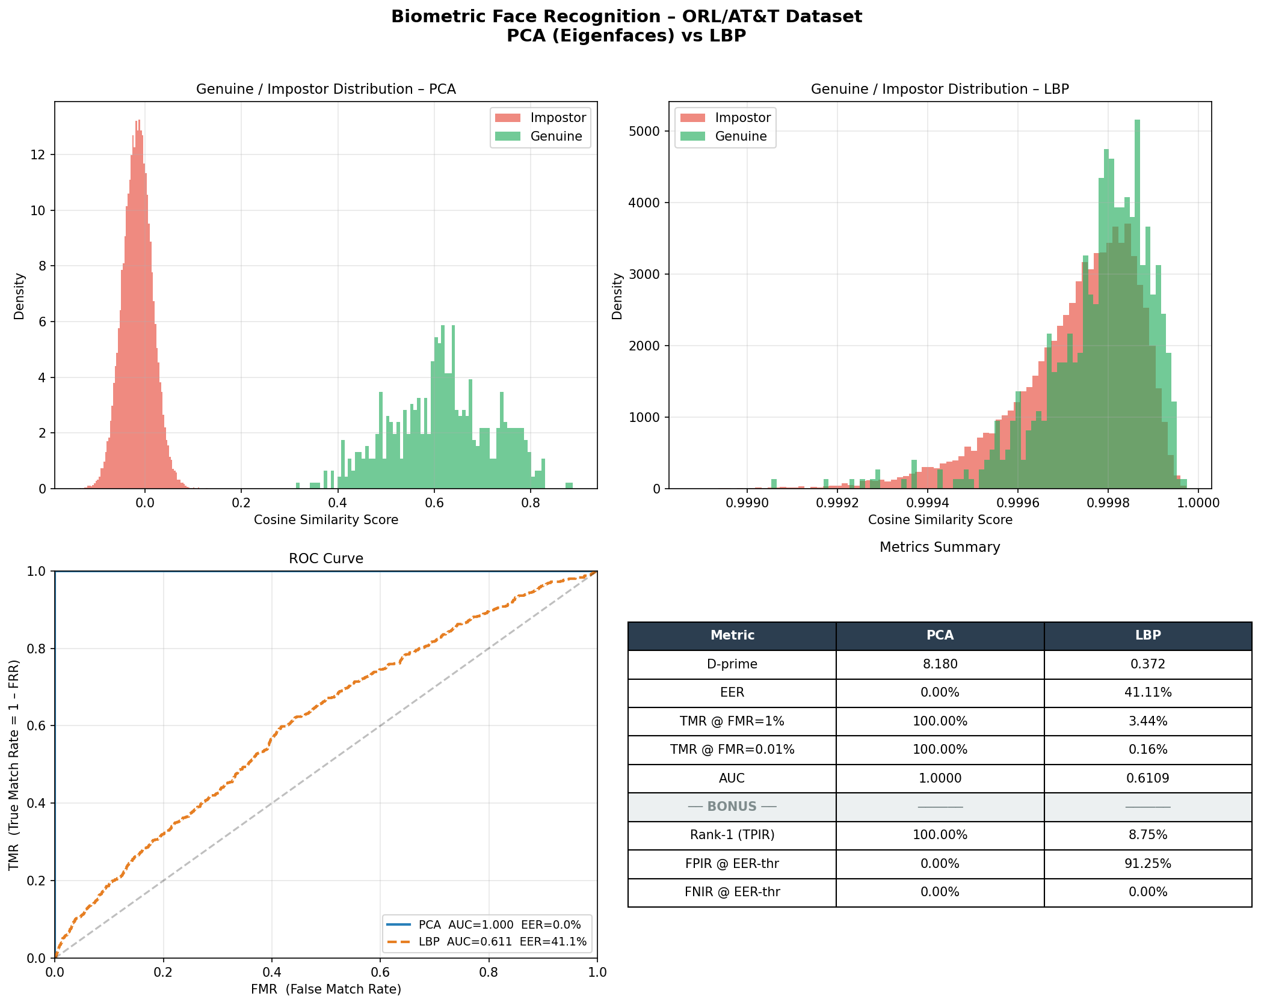
Figure 1: Gen/Imp distributions and ROC curves for PCA and LBP.

3.3 Discussion
PCA (Eigenfaces) achieved near-perfect performance across every metric: D-prime of 8.18, EER of 0.00%, TMR of 100% at both FMR thresholds, and AUC of 1.0. This is consistent with the known strengths of Eigenfaces on controlled datasets: the Olivetti database has limited intra-class variation (same camera, similar conditions), which PCA handles exceptionally well by compressing the globally most discriminative facial structure into 100 components.

LBP performed poorly with an EER of 41.11%, D-prime of 0.37, and Rank-1 accuracy of only 8.75%. This outcome is expected: LBP's 18-dimensional histogram discards all spatial layout information, retaining only a global texture summary. Since face images from different subjects may share similar overall textures, LBP cannot reliably distinguish between individuals at this histogram resolution.

The Gen/Imp score distributions in Figure 1 visualise the separation clearly. For PCA, the genuine and impostor distributions are well separated with no overlap. For LBP, the distributions almost completely overlap, indicating the features carry little discriminative power. The ROC curve confirms this: PCA's curve hugs the top-left corner (AUC = 1.0) while LBP's curve lies close to the diagonal (AUC = 0.61), approaching random-chance performance.

4. Conclusion
This project implemented a complete biometric face recognition pipeline on the ORL/AT&T dataset, covering preprocessing, feature extraction, matching, score analysis, and both verification and identification evaluation.

Two feature extraction methods were compared. PCA (Eigenfaces) demonstrated outstanding performance, achieving perfect or near-perfect scores on every metric. Its ability to capture the global structure of face images in a compact, discriminative representation makes it highly effective for controlled-condition face recognition.

LBP, by contrast, performed poorly in this context. While LBP is valuable for texture classification tasks and is robust to local illumination changes, its fixed-size global histogram representation is insufficient for identity discrimination when faces have similar textures across subjects.

The identification (bonus) results reinforce this conclusion: PCA achieved 100% Rank-1 accuracy, correctly identifying every test probe in the gallery on the first match, with zero false positives and zero false negatives. LBP achieved only 8.75% Rank-1, with a 91.25% false positive rate.

Future improvements could include combining both methods (score-level fusion), using deeper LBP variants with multiple scales and spatial grids (multi-block LBP), or applying deep learning approaches such as FaceNet or ArcFace for real-world scenarios with greater variation.

References
[1] Samaria, F. S., & Harter, A. C. (1994). Parameterisation of a stochastic model for human face identification. Proceedings of the 2nd IEEE Workshop on Applications of Computer Vision.

[2] Turk, M., & Pentland, A. (1991). Eigenfaces for recognition. Journal of Cognitive Neuroscience, 3(1), 71–86.

[3] Ojala, T., Pietikainen, M., & Maenpaa, T. (2002). Multiresolution gray-scale and rotation invariant texture classification with local binary patterns. IEEE Transactions on Pattern Analysis and Machine Intelligence, 24(7), 971–987.

[4] Pedregosa, F., et al. (2011). Scikit-learn: Machine learning in Python. Journal of Machine Learning Research, 12, 2825–2830.

